**Session 15: SCALA - SESSION IV**

**Assignment 15.2**

**Problem Statement**

1. Write a partial function to add three numbers in which one number is constant and two numbers can be passed as inputs and define another method which can take the partial function as input and squares the result.

**Scala Code**

package Assignment15_2

class PartialClass

{

def squareFunc(x: Int): Unit ={

println("Squares = "+ x*x) // defined a function to square the input's

}

def addition(x: Int,y: Int, z:Int)=x+y+z//a function to add constant+value1+value2

val add =addition(5,_:Int,_:Int) // the constant value = 5

def partialFunc(a: Int, b: Int): Unit ={ // another method to define a value for

constant

println("Addition = "+add(a,b))

squareFunc(add(a,b))

}

}

object partialFunctionObj{ // singleton object to call the functions

def main(args:Array[String]): Unit ={

println("Enter the value of the numbers: ")

var a:Int = scala.io.StdIn.readLine().toInt // reading the input value

var b:Int = scala.io.StdIn.readLine().toInt

new PartialClass().partialFunc(a,b) //

}

}

Here the constant is x and we defined the value of **x as 5**, we have two variables a and b, we pass **a=y=5** and **b=z=5**, we get the **x+y+z** = **5+5+5 = 15**.

15 is the output of the partial function is squared **15*15** in the **squareFunc** which is **225**.

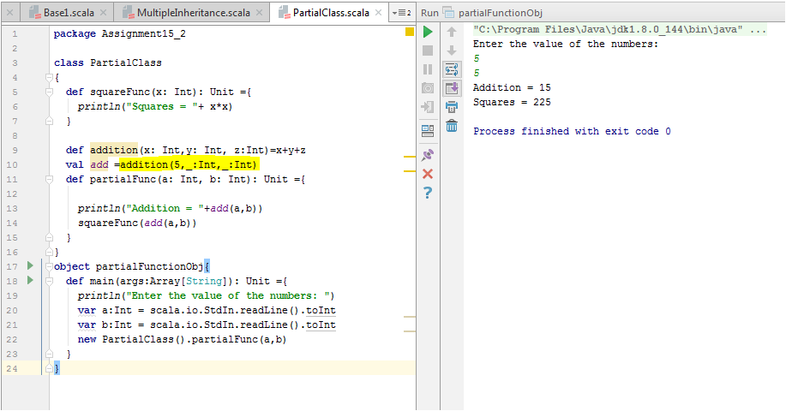

1. Write a program to print the prices of 4 courses of Acadgild: Android-12999, Big Data Development-17999, Big Data Development-17999, Spark-19999 using **match and add** a default condition if the user enters any other course.

**Scala Code**

package Assignment15_2

object patternmatch

{

def result(x: String):String = x match

{

case "Android" => ("Android course price is 12999/-")

case "Big Data Development" => ("Big Data Development price is 17999/-")

case "Big Data Development" => ("Big Data Development price is 17999/-")

case "Spark" => ("Spark prices is 19999/-")

case _=> ("This course is not available")

}

def main(args: Array[String]): Unit =

{

print(result("Big Data Development"))

} }

**OUTPUT** 